Total revenue

select sum(total_price) as total_revenue from pizza_sales

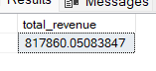

Average order value

select (sum(total_price) / count(DISTINCT order_id)) as Avg_order_value from pizza_sales

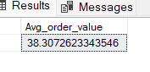

Total pizza sold

select sum(quantity) as TotalPizzaSold from pizza_sales

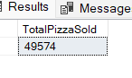

Total orders

select count(distinct order_id) as totalOrders from pizza_sales

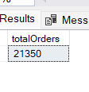

Average pizza per order

select cast(cast(sum(quantity) as decimal(10,2)) / (cast(count(distinct order_id) as decimal(10,2))) as decimal(10,2)) as avgPizzaPerOder from pizza_sales

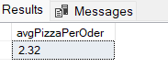

Daily trend for total orders

select DATENAME(DW,order_date) as order_date, count(distinct order_id) as total_orders from pizza_sales

group by datename(dw,order_date)

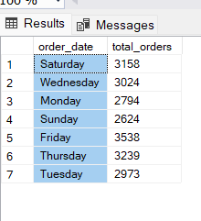

Monthly trend for total orders

select datename(month , order_date) as month_name, count(distinct order_id) as total_orders from pizza_sales

group by DATENAME(month, order_date)

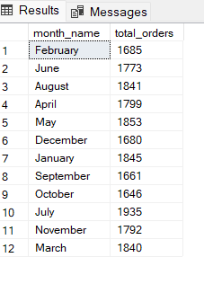

Percentale of sale by pizza category

select pizza_category, cast(sum(total_price) as decimal(10,2)) as total_revenue,

cast(sum(total_price)*100/(select sum(total_price) from pizza_sales) as decimal(10,2)) as PS

from pizza_sales

group by pizza_category

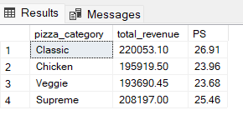

Percentage sale by pizza size

select pizza_size, cast(sum(total_price) as decimal(10,2)) as total_revenue,

cast(sum(total_price)*100/(select sum(total_price) from pizza_sales) as decimal(10,2)) as PS

from pizza_sales

group by pizza_size

order by pizza_size

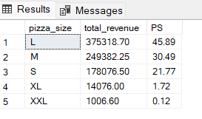

Total pizza sold by pizza category

select pizza_category, sum(quantity) as TPSBC from pizza_sales

group by pizza_category

order by TPSBC desc

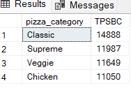

TOP 5 Best Sellers BY revenue

select top 5 pizza_name,sum(total_price) as total_revenue from pizza_sales

group by pizza_name

order by total_revenue DESC

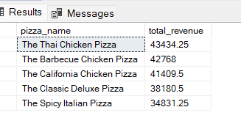

Bottom 5 revenue

select top 5 pizza_name,sum(total_price) as total_revenue from pizza_sales

group by pizza_name

order by total_revenue ASC

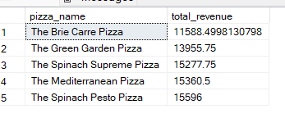

Top 5 total quantity

select top 5 pizza_name, sum(quantity) as totalQ from pizza_sales

group by pizza_name

order by totalQ DESC

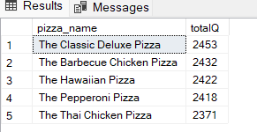

Bottom 5 total quantity

select top 5 pizza_name, sum(quantity) as totalQ from pizza_sales

group by pizza_name

order by totalQ asc

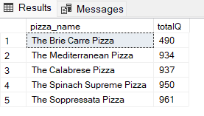

top 5 total order

select top 5 pizza_name, count(distinct order_id) as totalOrder from pizza_sales

group by pizza_name

order by totalOrder desc

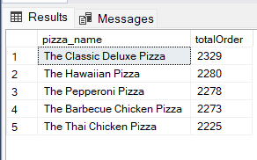

Bottom 5 total order

select top 5 pizza_name, count(distinct order_id) as totalOrder from pizza_sales

group by pizza_name

order by totalOrder asc

